United States Office of Personnel Management

**CFC Donor Pledge System**

**User Guide**



**Table of Contents**

**How to Use This Manual** 1

**CFC Zones** 2

**CFC Approved Charities** 2

**User Overview** 2

**To create an online pledge for this year’s CFC campaign**: 2

**Navigation Guide** 4

**Creating an Account** 5

**Signing In (Returning Users)** 8

**Creating a New Pledge** 9

**Copying an Existing Pledge** 15

**Volunteering** 20

**USPS Employees Updating SSN to EIN** 21

**Establishing Your Pledge Payment Source(s)** 22

**Adding a Payroll Account** 23

**Adding a Credit or Debit Card:** 24

**Adding a Bank Account** 25

**Reviewing Transaction History Details** 26

**Printing Tax Receipts** 28

**Updating Your Profile Information** 29

**Updating Personal Information** 30

**Editing or Adding an Email** 31

**Changing Your Password** 33

**Updating Security Questions** 35

**Editing or Canceling a Pledge** 37

**To Edit A Pledge** 39

**To Cancel a Pledge** 40

**Retrieving Forgotten User Name** 41

**Requesting Temporary Password** 42

**Submitting Group Volunteer Pledge** 43

**Reporting Group Volunteer Hours Completed** 47

**Text to Give** 49

# **How to Use This Manual**

The CFC Donor Pledge System User Guide is being provided to help users navigate through the CFC pledging process. The Table of Contents on the preceding page lists the tasks considered in this volume. The User Overview and Navigation Guide provide a summary of site usage, followed by more detailed, step-by-step instructions provided for each common task.

Information provided in each section is relevant to a given task:

**Task Category (*e.g.*, printing tax receipts)**

Under Task Category, you will find that the system provides a summary of the task along with helpful screenshots and step-by-step instructions. Users will find Site Features written *in italics* for clarity. Red boxes highlight tabs that need to be selected to move forward or important information on the screen.

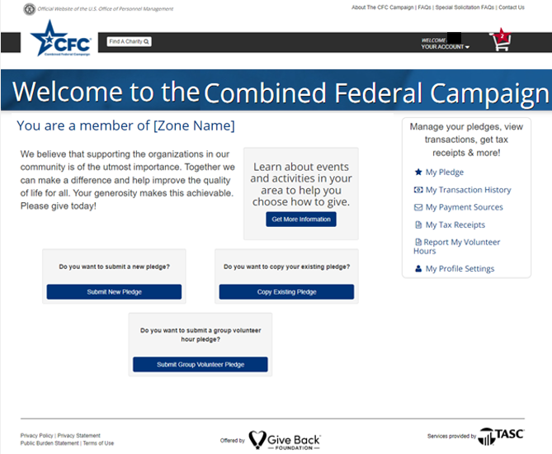

*Example Task Instructions*

1. While signed in, select *Tax Receipts* listed under your account management options.
2. Your most recent tax receipt will be displayed.
3. Scroll down to the bottom of the screen and select the *Print Tax Receipt* tab.
4. You can print your tax receipt from this page for your records.

# **CFC Zones**

The term ‘zone’ is used to describe CFC programs in various geographical regions. Users are assigned a zone based on work location. The assignment to a Zone helps personalize the user experience as unique zone news pages will have information on upcoming events and activities in a donor’s area.

# **CFC Approved Charities**

Before the campaign season, nonprofit organizations apply to participate in the CFC. Users can only donate to organizations that have applied and met the CFC’s eligibility requirements.

To be eligible to participate in the CFC, the U.S. Internal Revenue Service must recognize a charitable organization as a tax-exempt non-profit organization under 26 U.S.C. 501(c)(3) of the Internal Revenue Code. An application to participate in the CFC must provide specific information about the organization's accounting, governance, and program functions as specified in the CFC regulations at 5 CFR §950. The organization must also provide a complete and signed copy of its IRS Form 990 for the most recent fiscal year. Organizations must also demonstrate that they provide services in the service area to which they are applying.

To search through eligible organizations, use the search feature available through the CFC Donor Pledging System at[**https://cfcgiving.opm.gov/welcome**](https://cfcgiving.opm.gov/welcome)

Users do not have to be registered to search through the database of eligible charitable organizations.

# **User Overview**

## **To create an online pledge for this year’s CFC campaign**:

1. Visit [**https://cfcgiving.opm.gov/welcome**](https://cfcgiving.opm.gov/welcome) to register or sign in to an existing account and submit a pledge.

* New users should select the *Sign Up Now* tab and follow the prompts provided while filling in the information required to sign up.

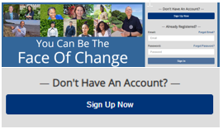

1. Navigate through the site via easy-to-access account management options available on the user home page, or in the drop-down menu under *Your Account* in the top right-hand section of each page.

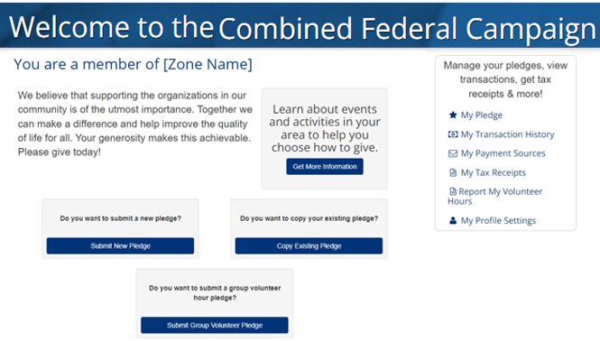

1. Establish pledge methods by selecting *Payment Sources* and entering the information requested for the method(s) you would like to use to fund your donations.
2. Create a pledge by selecting *Submit a New Pledge or Copy Existing Pledge* on the home page. Select your charities, then choose your payment method and frequency. Also, designate how you wish to distribute your donations to each charity you select. Submit to finalize.

# **Navigation Guide**

The graphic below indicates the different navigation points located on the home screen and the functionality available from those points.

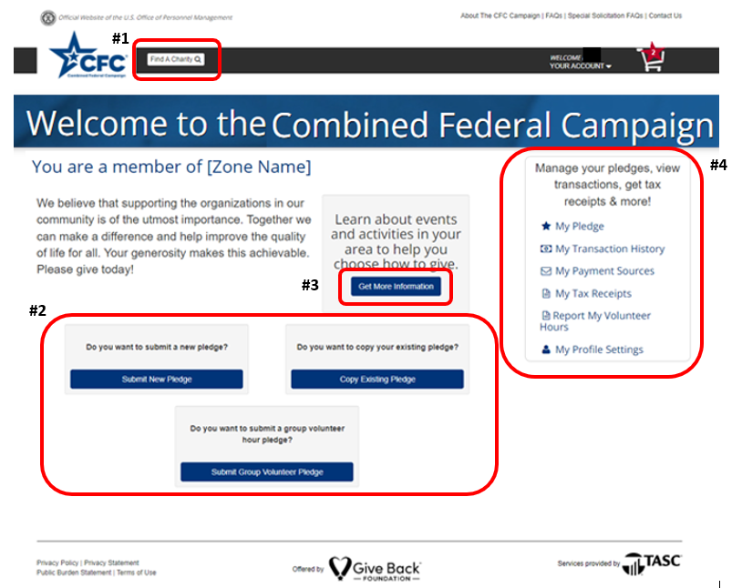

1. Search for a Charity
2. Options for pledging:
   1. New Pledge
   2. Copy Existing Pledge from a prior campaign
   3. Create a Group Volunteer Pledge
3. See the assigned CFC Zone News Page
4. Quick links for Account Management
   1. *My Pledge*: Review, change, or cancel pledge information
   2. *My Transaction History*: Review payments made and donation statuses
   3. *My Payment Sources*: Update payment method
   4. *My Tax Receipts*: Print Tax Receipts
   5. *My Profile Settings*: Update personal information, add a secondary email, reset password, or reset security questions.

# **Creating an Account**

New users should access the CFC Donor Pledging System at [**https://cfcgiving.opm.gov/welcome**](https://cfcgiving.opm.gov/welcome)

To sign up:

1. Select and click on *Create an Account*

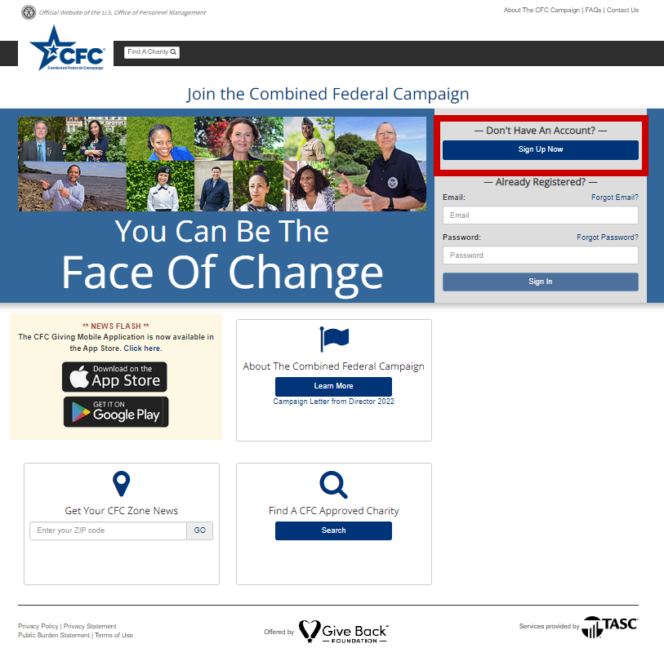

1. New users will then be asked to enter their email and select a password. Users may provide either a government or personal email for this purpose.
2. Fill in the blanks with the information required and check the box below agreeing to the Privacy & Terms and Conditions of Use.
3. Passwords must be eight (8) characters long and include one uppercase letter, one lowercase letter, one number, and one special character.
4. Both the Privacy & Terms and Conditions of Use are available for review. To access it, click the document title which links to the full content.

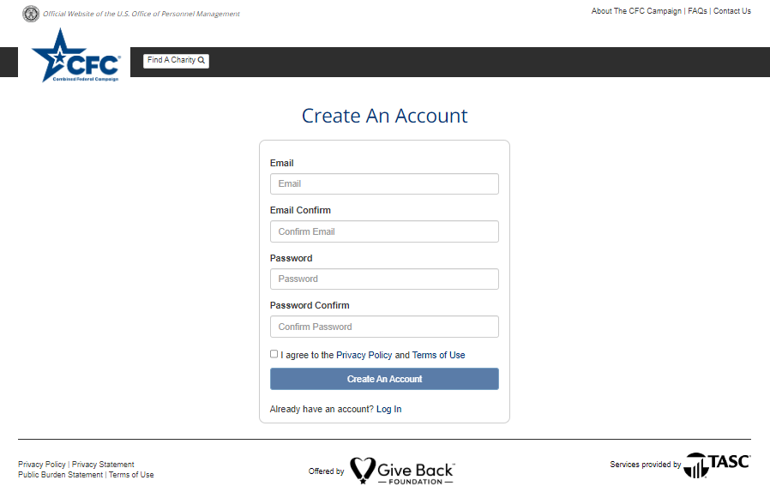

1. The Online Donation System will send a verification PIN to the email address provided. Follow the link provided, enter the PIN, and continue to follow the site prompts to complete your sign-up process. Please note that the verification PIN will only be valid for 24 hours. If you do not verify your account in this timeframe, you will need to request a new code.

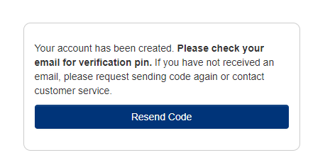

1. You will be asked to select and answer a few security questions. Select questions and note the answers used.

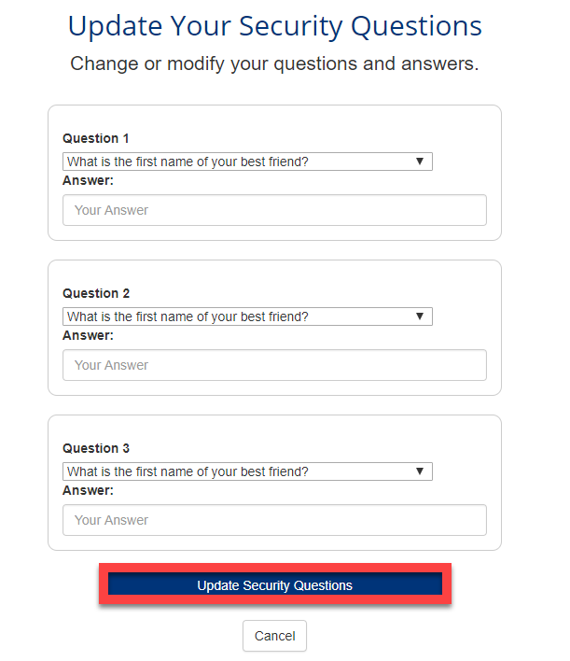

1. Complete your user profile:

* Under *Type of Donor* select either Federal Employee, Retiree/Beneficiary, or Federal Contractor, depending upon your employment status.
* The system will require different information depending on the donor type.
* All fields are required (except for a secondary email):

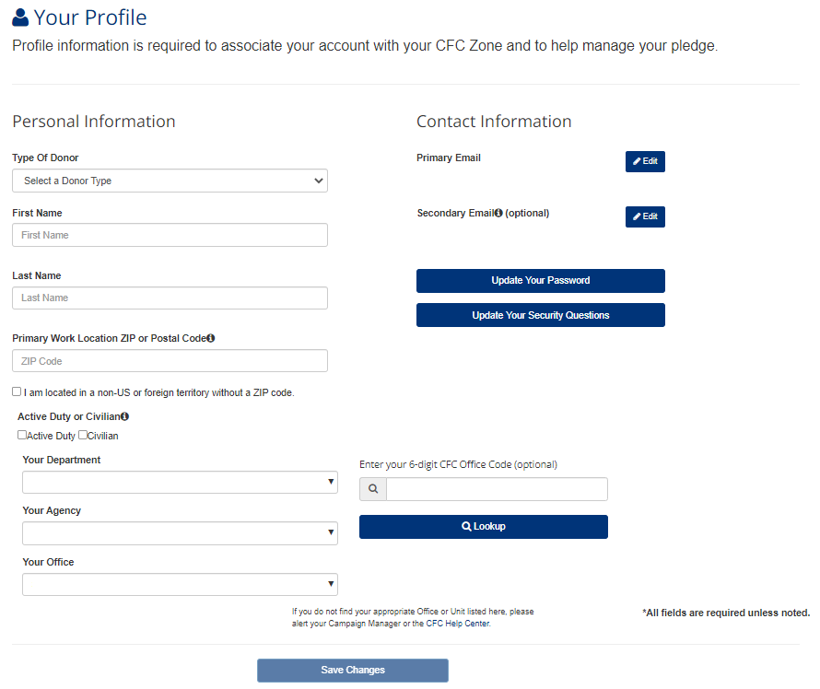

1. When done, select and click on Save Profile, and your account will be ready for you to set up your pledge.

# **Signing In (Returning Users)**

Users with pre-established accounts should access the CFC Donor Pledging System at [**https://cfcgiving.opm.gov/welcome**](https://cfcgiving.opm.gov/welcome) and sign in using the email and password they selected during the setup process.

To sign in:

1. Return to the CFC Campaign website
2. Enter the email used during signup
3. Enter the password chosen during the signup
4. Select and click on *Sign In*

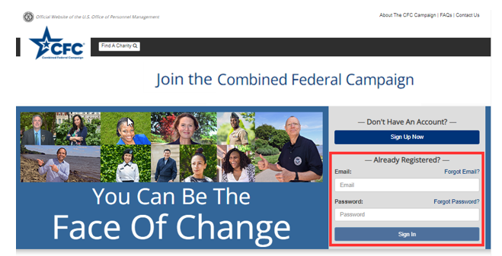

After selecting *Sign In,* Users land on their Home Page.

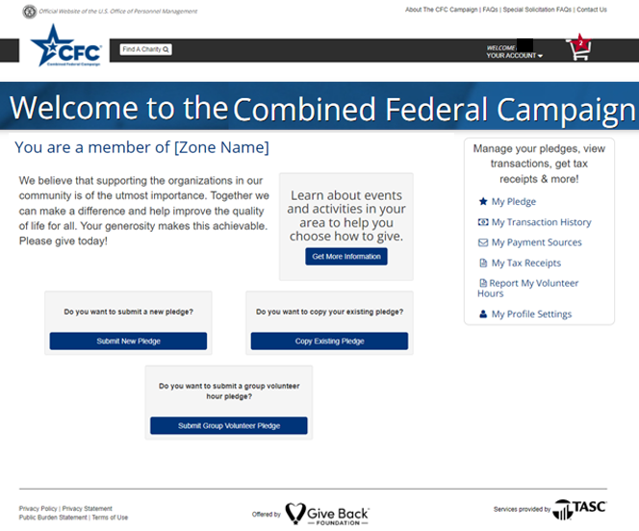

# **Creating a New Pledge**

Establish individual giving for the plan year by creating a pledge.

* Users can give on a one-time basis or establish scheduled giving.
  + Only one recurring payroll pledge is allowed.
  + Multiple recurring or one-time pledges are allowed when funded via credit card or ACH.
* One-time pledges are processed immediately and may take up to 3 or 4 business days to settle from the date the pledge is submitted. Donors may fund a one-time pledge through a credit card or bank account.
* Ongoing or recurring giving is processed monthly starting in the same month after the official solicitation period ends of the campaign year. Users may fund these recurring gifts through payroll deduction, a credit card, or a bank account.
  + Recurring giving processed via credit card or bank account will occur monthly.
  + Recurring giving processed by payroll deduction will begin with the user’s first payroll date following the end of the official solicitation period.

1. To create an individual pledge, select *Submit a New Pledge* ***OR*** *Copy Existing Pledge* on the home page.

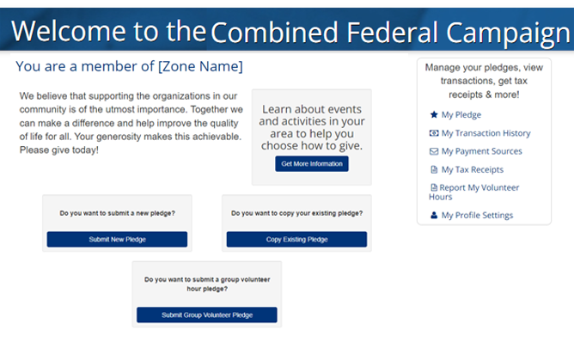

1. Search for charities.

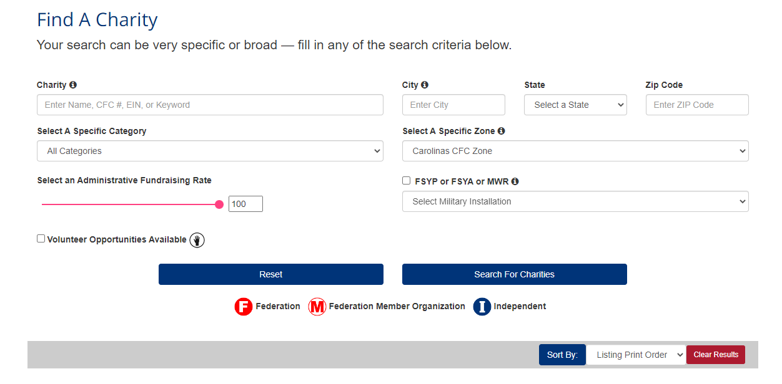

Search by:

* **Charity –** Name, CFC #, EIN, or keyword
* **Location Near –** City, state, or ZIP Code
* **Select a Category –** Organizations are sorted by categories such as education, healthcare, and public safety
* **Select a Zone –** Choose from organizations in a specific CFC regional zone
* **Select an Administrative Fundraising Rate –** The fundraising rate is the percentage of funding that goes to management and administrative work.
* **FSYP, FSYA, and MWR Only –** Organizations with a military association
* **Volunteer opportunities available –** Select this box to search those organizations that accept volunteers

Once you enter or choose the criteria, click on *Search for Charities*.

1. Add charities to your cart by selecting the Add tab with the star icon located to the left of the charity name.

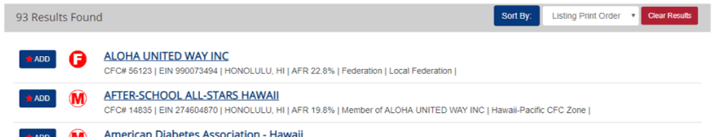

Sort your results by selecting the *Sort By* tab. You can sort the results by Listing Print Order, Name, EIN, CFC code, City, Category, Zone, or AFR.

1. The site will confirm that you saved the charity to your Pledge Cart.

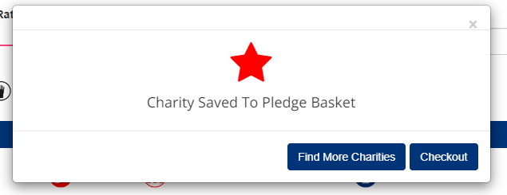

1. Once done adding charities, select and click on Checkout.
2. Once in the Pledge Cart, select a method and frequency for your pledge from the drop-down menu. Depending on the method chosen, different frequencies will be available.
3. Set the pledge amount. Filling in the annual amount will populate the other frequency amounts and vice versa.

Note: Minimum contribution amounts via payroll deduction are $1 per pay period per charity. The minimum credit card donation is $10. The maximum online contribution is $999,999. However, certain payroll service providers may limit the maximum amount of a payroll deduction gift. For example, active-duty members of the Army, Navy, and Air Force may not pledge more than $9,999 annually). If wishing to donate an additional amount, please contact OPM for instructions.

1. Finally, select what percentage of the pledge should be allocated to each charity, enter any amount of volunteer hours desired, and choose whether to include donor information.

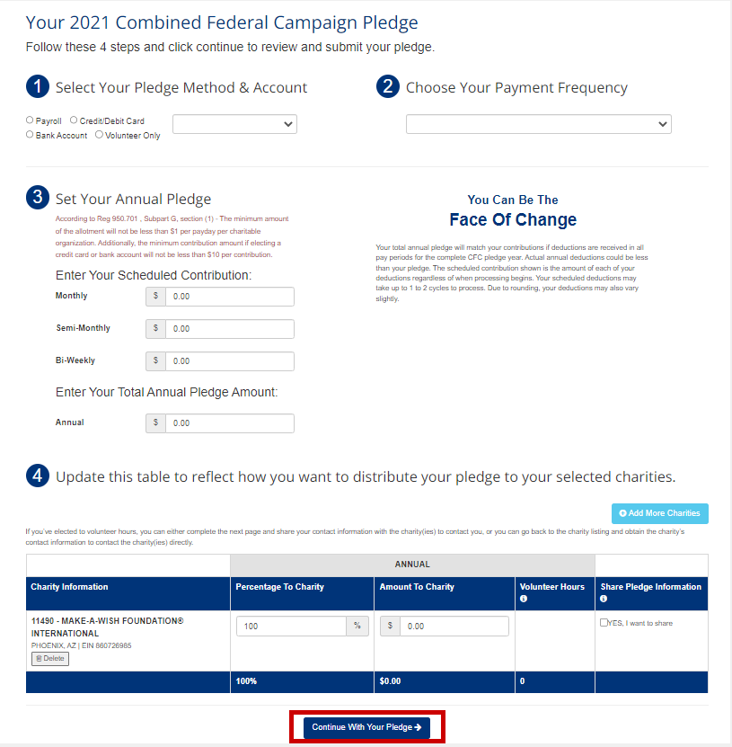

1. When you complete the form, click Continue With Your Pledge.

Note: By default, donations are anonymous unless you select/check the *YES, share my information* box, AND enter the address information on the following Information Sharing page.

1. If “Yes,” and a share my information option is selected, enter the information to be shared with the charities on the Information Sharing page.

* Users can choose to share pledge amounts, email, volunteer hours, and home address information.
* Keep information private by deselecting the associated box(es).
* Include only personal emails; do not include government-issued emails
* If you elect to volunteer for an organization, you may wish to share your contact information for the charity to contact you. Otherwise, you will need to contact the charity directly

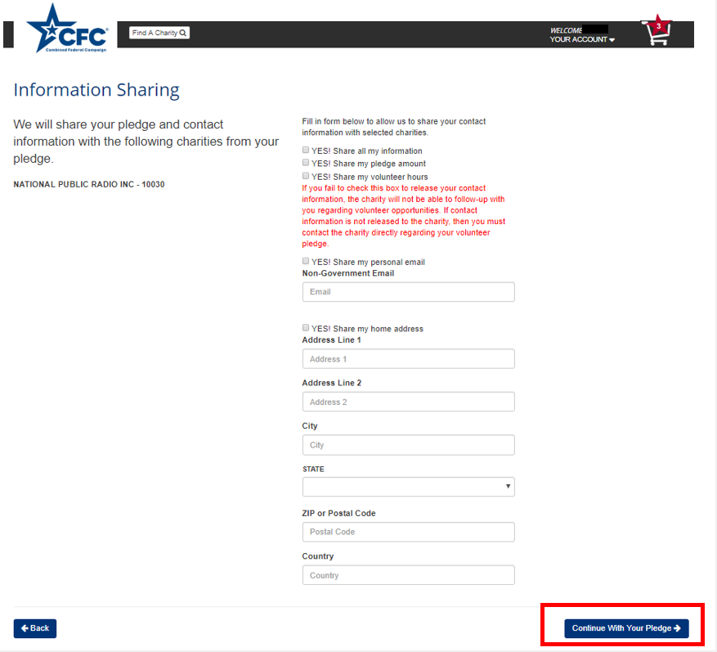

1. When done, select and click on *Continue with Your Pledge*.
2. Finally, you’ll be asked to confirm your pledge. Check the box next to *Confirm My Pledge* and select and click on *Submit Pledge* to finalize.

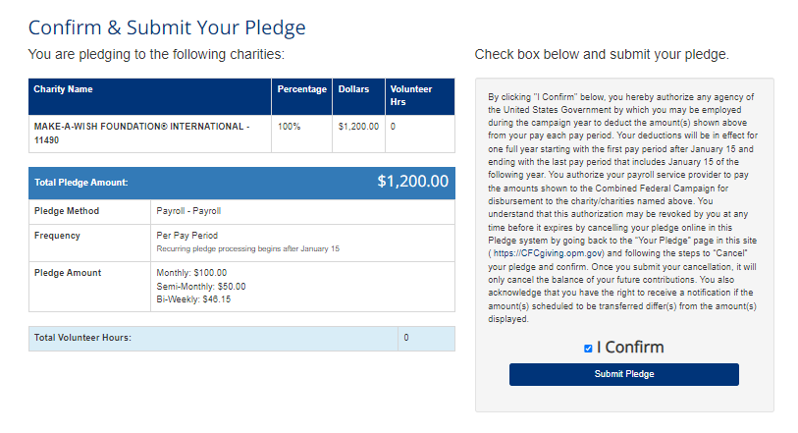

1. The next message confirms “Your Annual Pledge” a second time:

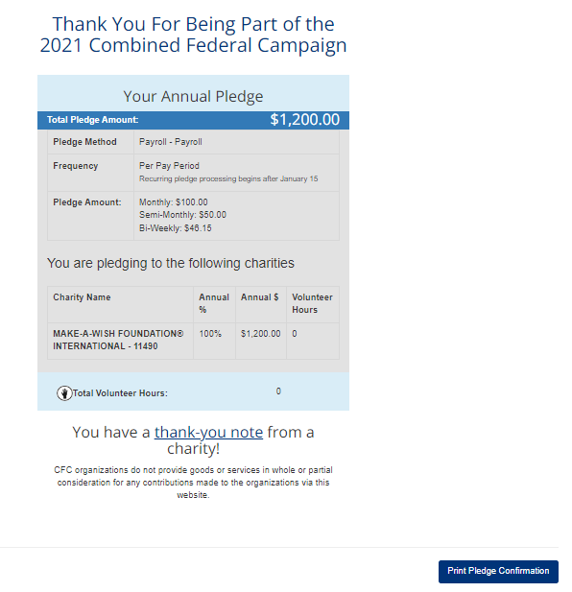

# **Copying an Existing Pledge**

A user can establish an individual giving for the plan year by copying an existing pledge from a prior year.

* Users can give on a one-time basis or establish scheduled giving.
  + Only one recurring payroll pledge is allowed.
  + Multiple recurring or one-time pledges are allowed when funded via credit card or ACH.
* One-time pledges are processed immediately and may take up to 3 or 4 business days to settle from the date the pledge is submitted. Donors may fund a one-time pledge through a credit card or bank account.
* Ongoing or recurring giving is processed monthly starting in the same month after the official solicitation period ends of the campaign year. Users may fund these recurring gifts through payroll deduction, a credit card, or a bank account.
  + Recurring giving processed via credit card or bank account will occur monthly.
  + Recurring giving processed by payroll deduction will begin with the user’s first payroll date following the end of the official solicitation period.

1. To copy an existing pledge, select and click on *Copy Existing Pledge* on the home page.

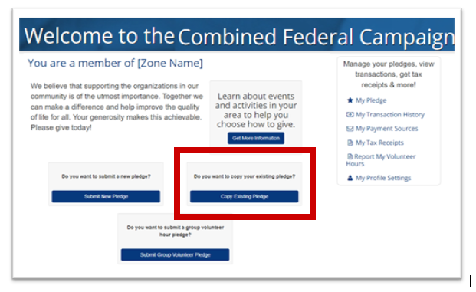

1. Select *Existing Pledge* from the Campaign and Pledge Dropdowns to copy
2. Click *Copy Pledge* to copy the selected prior year pledge

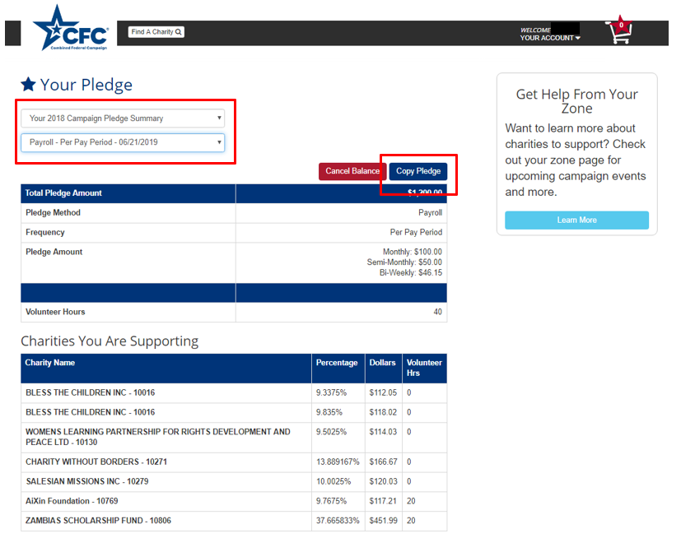

1. Click *Continue with Copy* to place copied pledge into your Pledge Cart

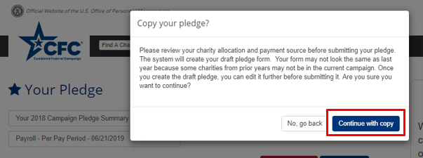

1. Your pledge card will be displayed with the copied pledge details.
   1. Select a new payment method & frequency if your previous payment source is in an error state for the copied pledge **or** you wish to change how your pledge will be funded.
   2. You will not see payroll as a payment method if you have already submitted a payroll pledge for the current campaign.
   3. You will see an error message if any of the charities from your copied pledge, are no longer participating in the current campaign.
   4. Select *Continue with Your Pledge* once all information is confirmed correct.

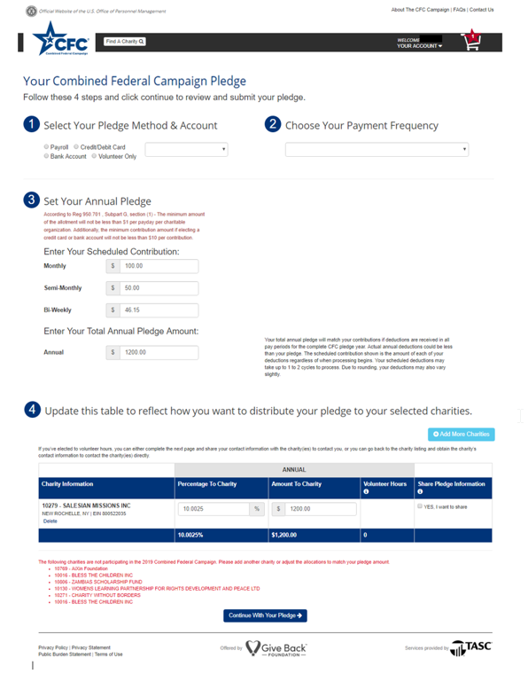

**Note**: By default, donations are anonymous unless you select/check the *YES, share my information* box, AND enter the address information on the following Information Sharing page

1. If yes, and a share my information option is selected, enter the information to be shared with the charities on the Information Sharing page.

* Users can choose to share pledge amounts, email, volunteer hours, and home address information.
* Keep information private by deselecting the associated box(es).
* Include only personal emails; do not include government-issued emails
* If you elect to volunteer for an organization, you may wish to share your contact information for the charity to contact you. Otherwise, you will need to contact the charity directly

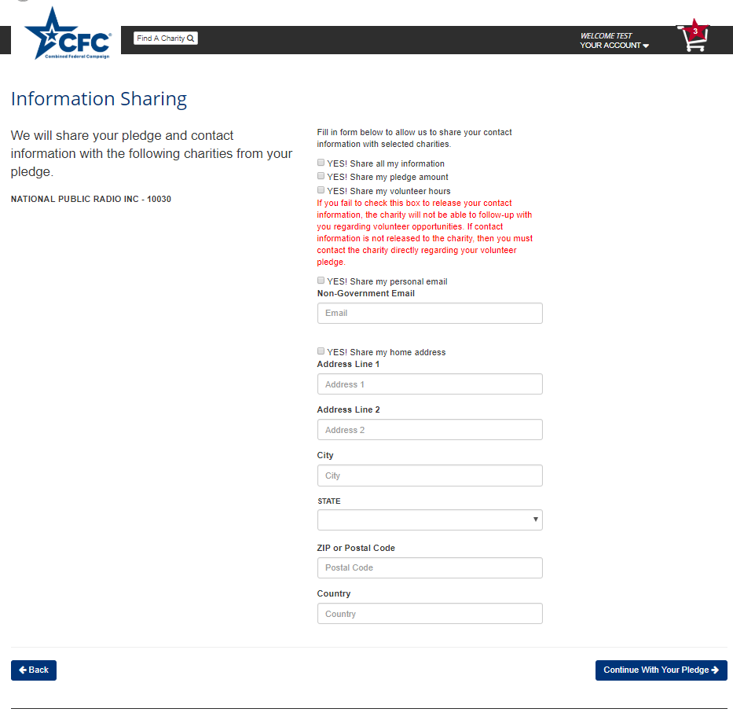

1. Reconfirm your pledge and click *Submit Pledge* to finalize your submission

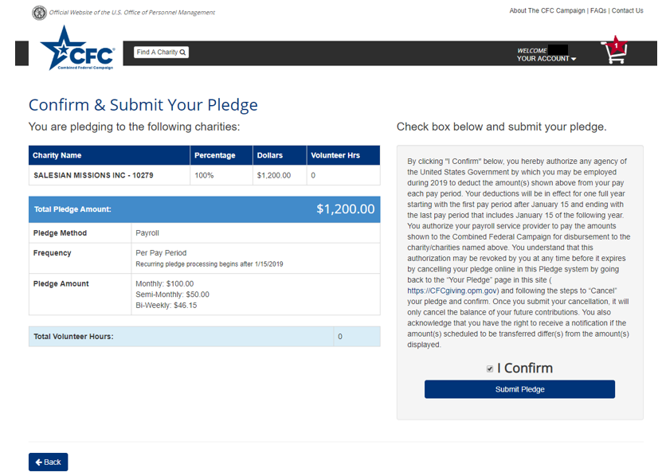

1. Click *Print Pledge Confirmation* to print this page for your records

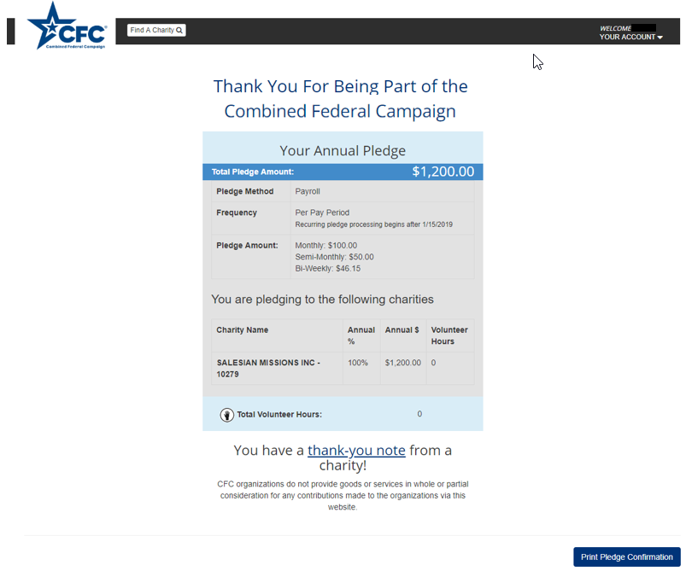

# **Volunteering**

In addition to pledging monetary donations, CFC donors can pledge time through the online volunteer features.

* When searching for organizations, check the *Volunteer Opportunities Available* box with the raising hand icon to search for organizations that are accepting volunteers.

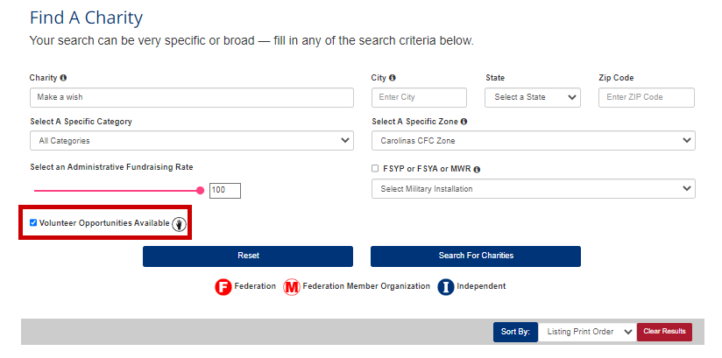

* When pledging, enter in the annual number of volunteer hours you intend to offer the charity. You must check the box to share your information with the charity and notify them you wish to volunteer. If you elect not to share your contact information, you will need to contact the charity directly to notify them of your pledge to volunteer time.

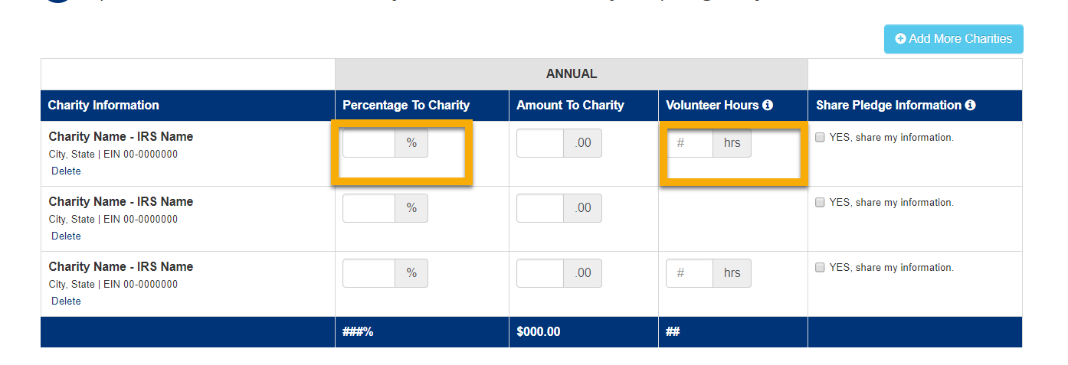

* To pledge volunteer hours without making a monetary donation, enter “0” in the P*ercentage to Charity* column for that charity.

## **USPS Employees Updating SSN to EIN**

If a USPS Employee enters the system that has not already updated their profile from using SSN to the employer-assigned EIN, they will be required to do so before finalizing a pledge for the new campaign.

1. Click *Payment Sources* on the homepage

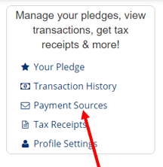

1. Click *Update* for the payroll account on the payment methods page

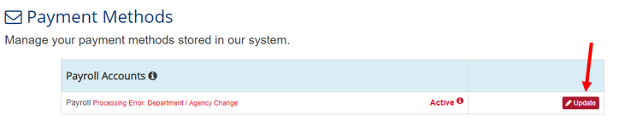

1. Enter USPS Assigned EIN and click *Add Payroll Account*

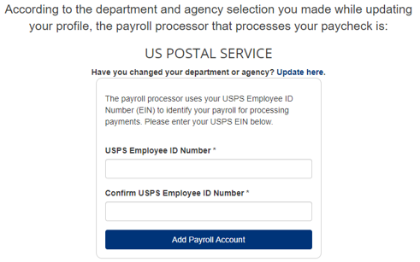

1. Payroll Payment Method will no longer show in Error

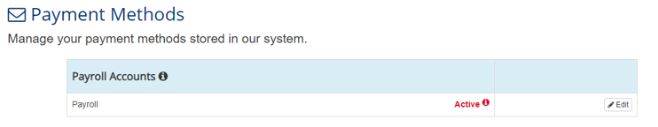

# **Establishing Your Pledge Payment Source(s)**

For an optimal experience, begin by establishing a payment source to fund your pledge. You do not need to establish all payment sources. Only establish those sources which you will use to fund contributions.

*A payroll account* can only be used to fund recurring donations. *Credit or Debit Card* and *Bank Accounts* can fund both one-time and recurring donations.

To establish a payment source:

1. Select *My* *Payment Sources* under the options provided.

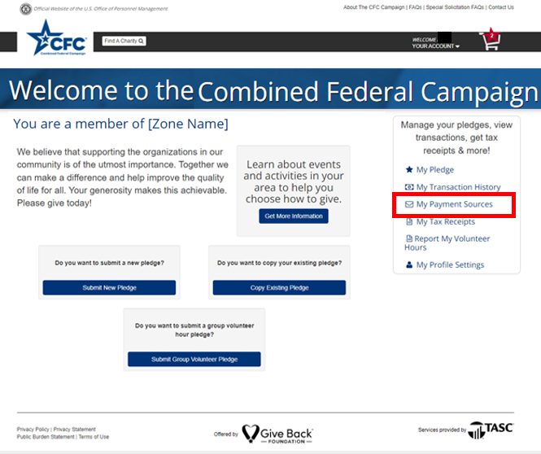

1. From *Payment Sources,* select a method to fund your pledge. Different types of users will have different options available. You cannot delete Payment Sources associated with an active pledge.

* Federal contractors will not be eligible for payroll deductions.

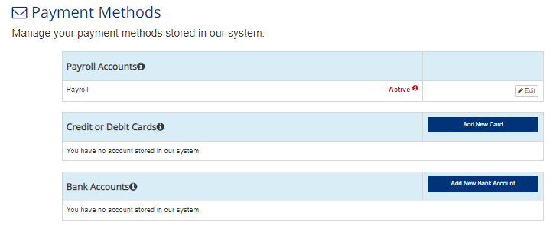

## **Adding a Payroll Account**

1. While in the *Payment Sources* section, select and click on *Add New Payroll Account* under *Payroll Accounts*.
2. Enter your Social Security number (USPS assigned EIN if applicable) twice for confirmation and press *Add Payroll Account*.

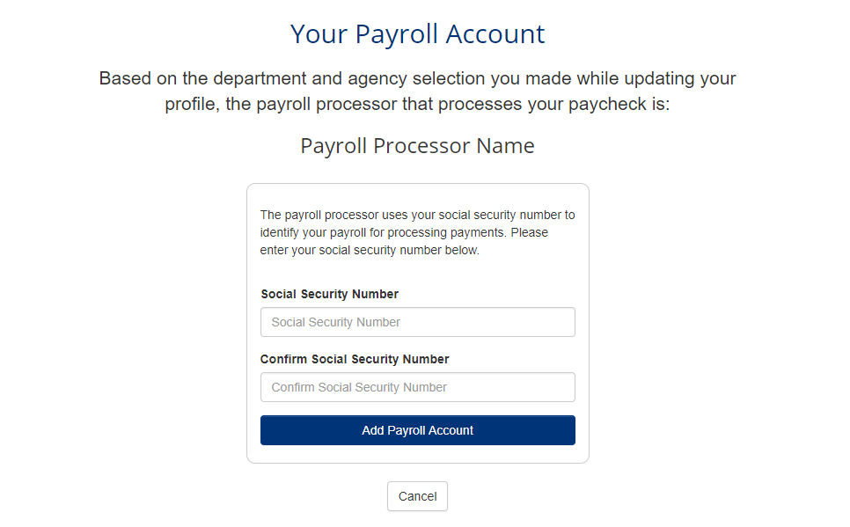

1. The system will establish a payroll connection based on your Social Security number and the department, agency, and office information entered during signup.

1. The payroll option you selected will then show in Payment Sources.

## **Adding a Credit or Debit Card:**

1. While in the *Payment Sources* section, select *Add New Card* under *Credit or Debit Cards.*
2. Enter all necessary information:

* Type of Card
* Name on Card
* Card Number
* Confirm the Card Number
* CVV – a three- or four-digit security code located on the front or the back of the card.
* Expiration Date – Month and year
* Billing postal code

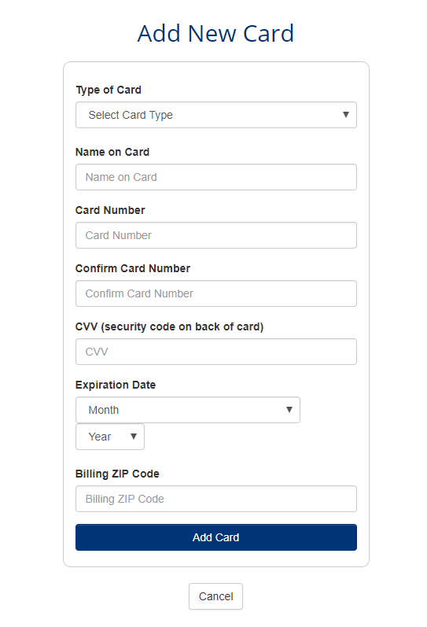

1. Select and click on *Add Card* to complete.
2. Under available methods in *Payment Sources,* you will find the card listed.

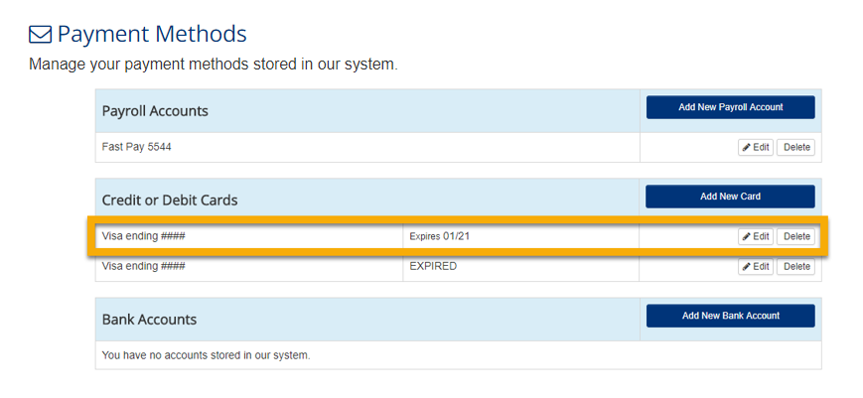

## **Adding a Bank Account**

1. While in the *Payment Sources* section, select *Add New Bank Account* under *Bank Accounts*.
2. Enter all necessary information:

* Name of Bank Account
* Bank Account Number
* Confirm Bank Account Number
* Bank Routing & Transit Number
* Billing Zip Code

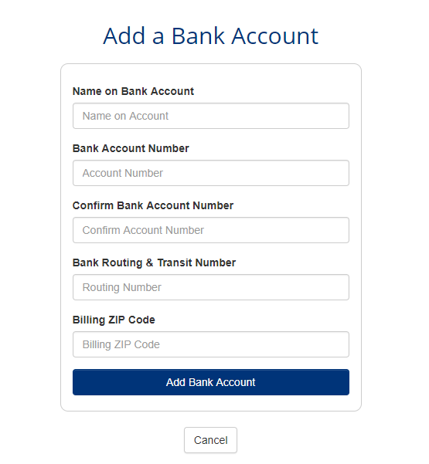

1. Select and click on *Add New Bank Account*
2. Under available methods in *Payment Sources,* you will find the Bank Account listed.

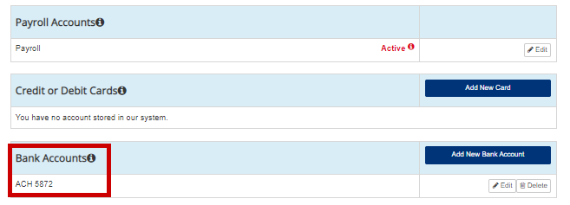

# **Reviewing Transaction History Details**

Once the CFC processes a contribution, transaction records will be available for review. To access these records:

1. Select *My Transaction History* from the account management options or drop-down menu under *Your Account*.

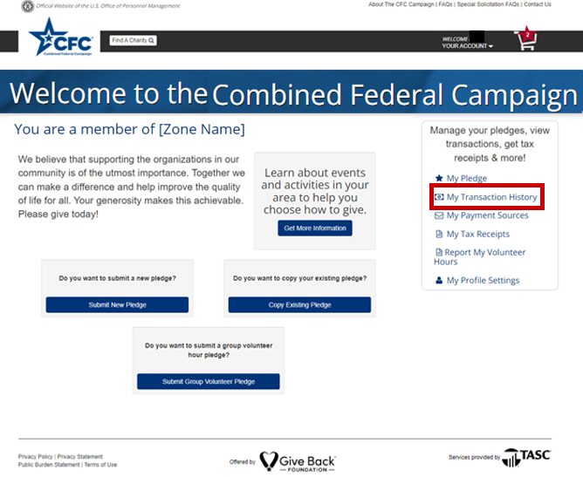

1. The *Transaction History* page will show a record of all processed contributions. To see more detail and the status of your disbursement of funds to the charities, select the down arrow to the right of *Disbursement to Charity* under the *Amount to Charity* column.

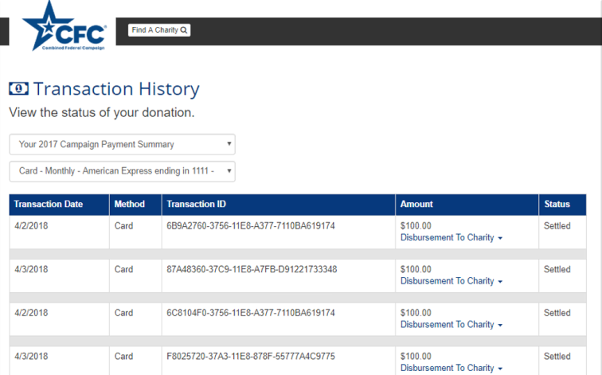

1. The system will then show all donations associated with a given contribution and display a donation status.

* The system shows donations *Pending Disbursement* that CFC has not yet sent to the charity.
* Donations *Disbursed* have been sent to the charity and will display the date settled.

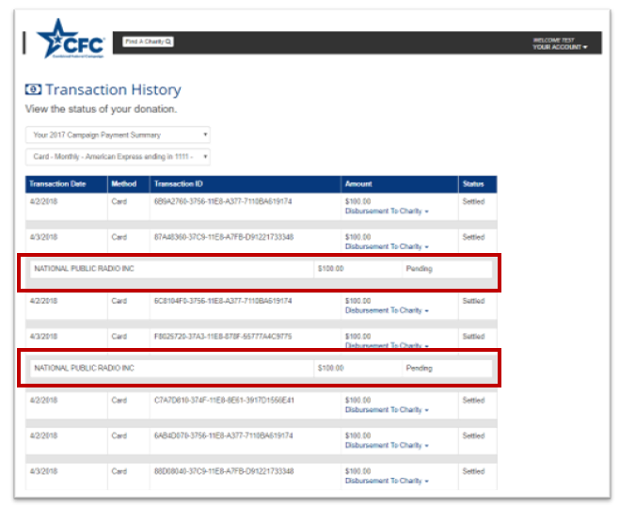

# **Printing Tax Receipts**

1. To print tax receipts for the year, select *Tax Receipts* from the account management options.

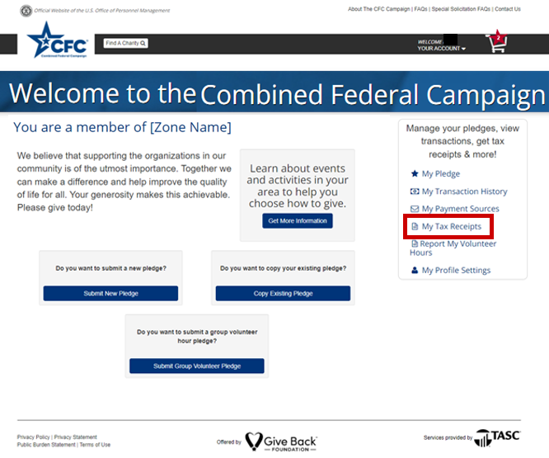

1. Select and click on *Print Tax Receipt* and either save or print a copy for your records.

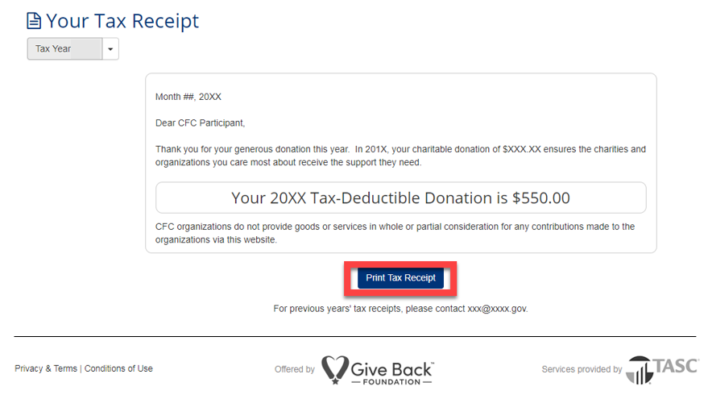

Note: Three years of tax receipts will be available from the drop-down menu at the upper left starting with any 2017 records. To obtain copies of your tax receipts before 2017, contact your Zone for the listing of your Principal Combined Fund Organization (PCFO).

# **Updating Your Profile Information**

1. To edit your personal information, select *Profile Settings* under the account management options.

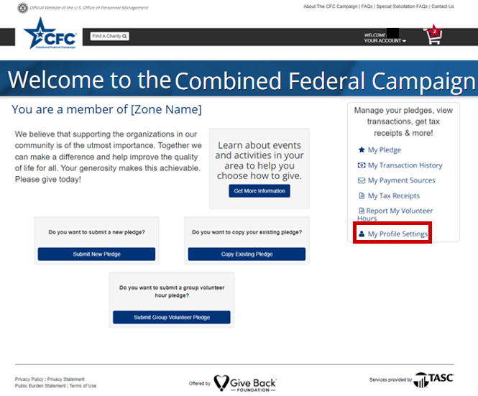

# **Updating Personal Information**

From the *Your Profile* page, you can change:

* Type of Donor
* First Name
* Last Name
* Primary Work Location ZIP Code
* Department
* Agency
* Office information

Note: Information captured will differ depending upon donor type. If Federal Employee status changes to Contractor due to a job transfer and as an Employee, payroll was the elected payment source, the payroll option will no longer be an available option under Contractor, and the user must select a new payment source in *Your Pledge* page. If this occurs after Official Solicitation ends, click on *Contact Us* in the upper-right-hand corner of the page for assistance.



Update any information needed and select and click on *Save Changes* to submit.

Note: If updating department, agency, or office information after a change in employment, be sure the user status is active in the new system and your transfer is complete before entering the change.

# **Editing or Adding an Email**

To edit your primary email or add a secondary email:

1. Select My *Profile Settings* under the account management options.



1. Enter your new primary (or secondary) email twice for confirmation and select and click on *Update Email Address*.

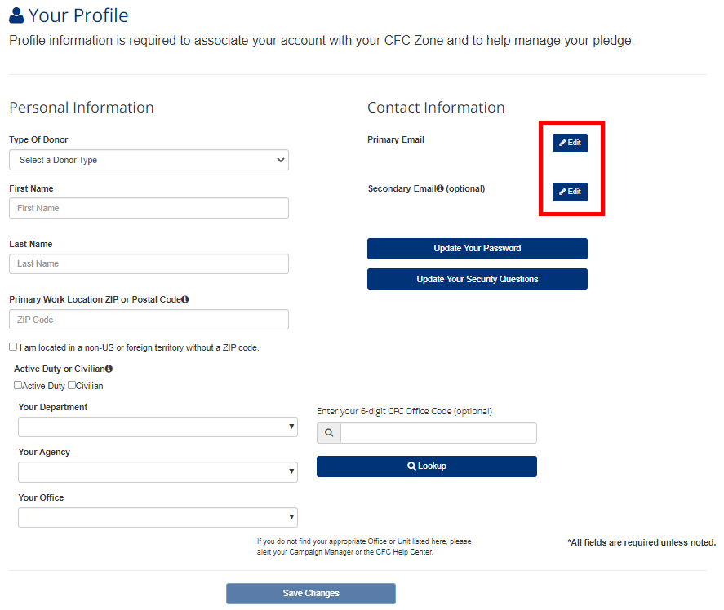

1. Enter your new primary (or secondary) email twice for confirmation and select and click on *Update Email Address*

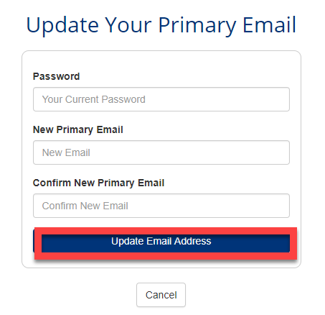

1. An email will be sent to verify the email address with a link for confirmation.

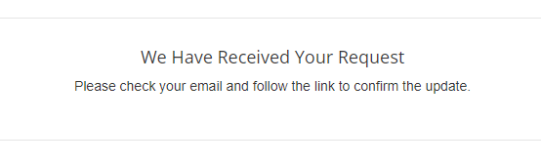

# **Changing Your Password**

To change your password, from the Your Profile screen:

1. Select *Update Your Password* on the *Your Profile* page.

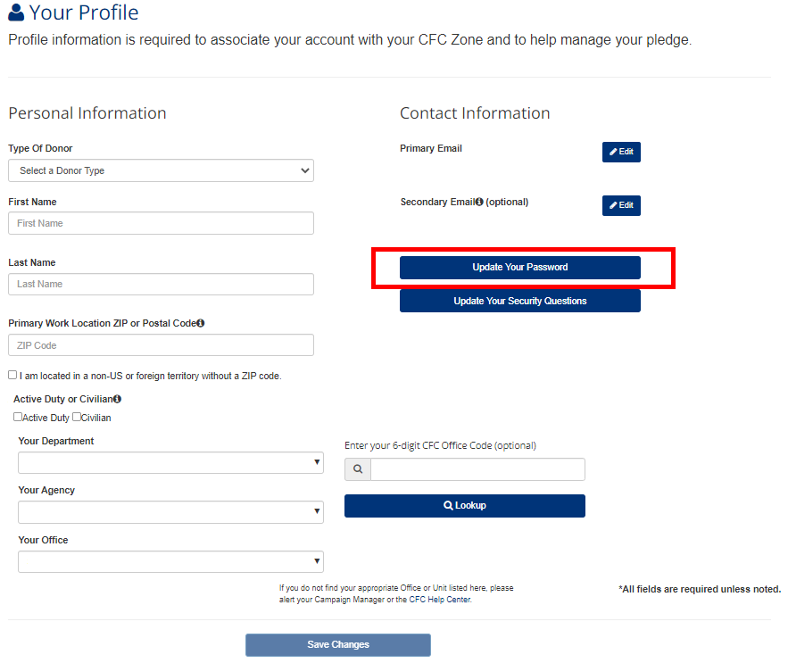

1. Enter your current password, and the new password twice for confirmation.

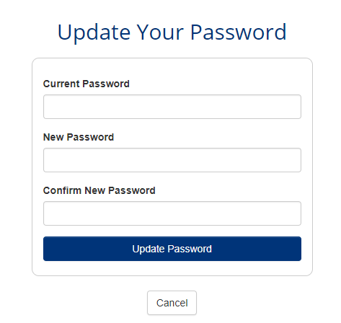

1. Select and click on *Update Password*.
2. The new password will be confirmed. Select and click on *Log In to Continue*.

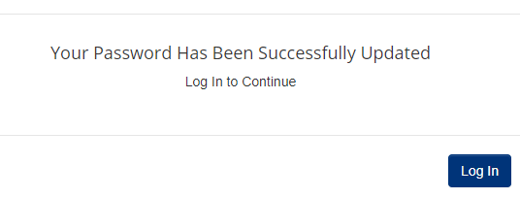

1. Enter the new password when logging in.

# **Updating Security Questions**

To change your security questions, from the *Profile* screen:

1. Select *Update Your Security Questions*.

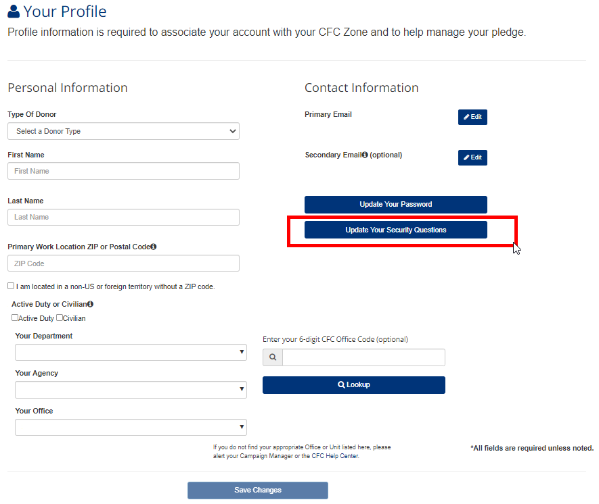

2. Select three questions and answers. Note your answers for future access. 

3. Select and click on *Update Security Questions*.

4. The new questions will be confirmed. Select and click on *Continue* to return to the *Profile* page.

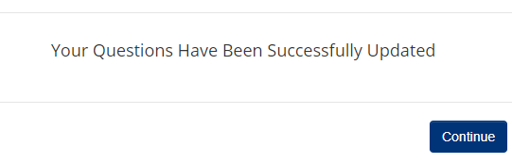

# **Editing or Canceling a Pledge**

Users can edit or cancel a recurring pledge at any time during the Official Solicitation Period. Users can not edit or cancel one-time donations made via a bank account or a credit card because CFC processes these immediately when submitted. After the Official Solicitation Period ends, recurring pledges can be canceled but not edited. Cancelations made online will be communicated to payroll providers. Users can only cancel pledge balances. Cancellations can take 1-2 payroll cycles to take effect.

1. Select *My Pledge* under the account management options.

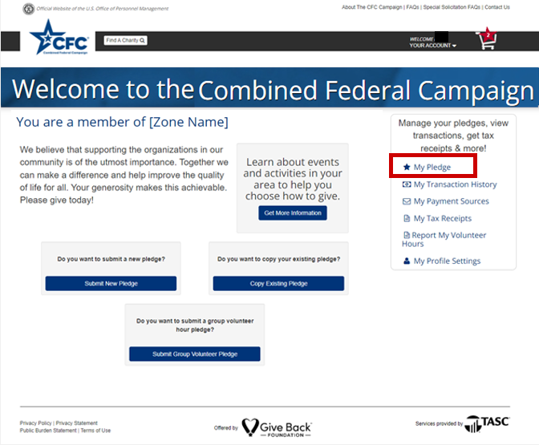

1. Select and click on either *Cancel* or *Edit Pledge* depending on the intended action.

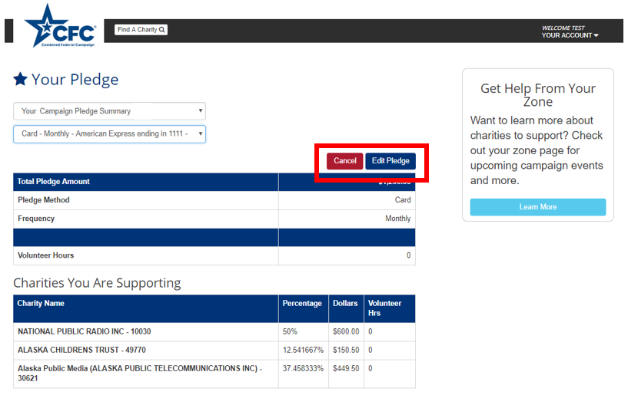

## **To Edit a Pledge**

1. Select *Edit Pledge*.

2. To complete your pledge, you will receive a notification explaining that once you select the *Edit Pledge* button, your pledge must be re-submitted. Select and click on *Continue with Edit*.

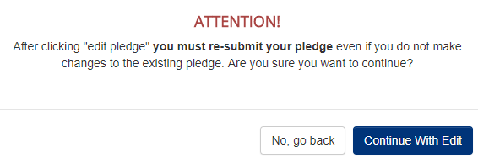

1. This tab will lead you back to the *Pledge Page* where you can change the payment method & account, update frequency, and redistribute donation percentages.

**Pledges can only be edited during the official solicitation period.**

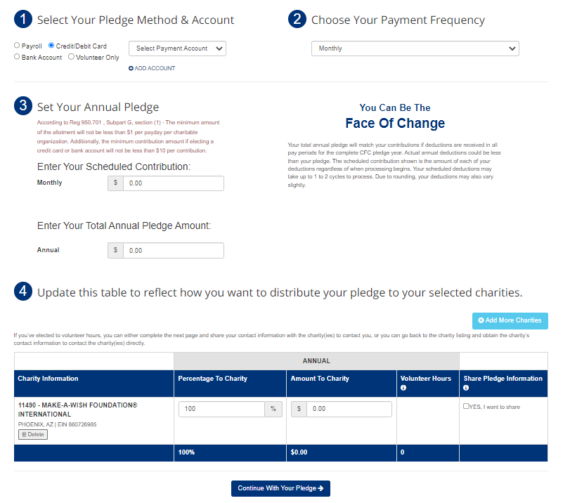

## **To Cancel a Pledge**

1. From *Your Pledge* screen, select and click on *Cancel* at the top right (see screenshot above).

2. If you cancel your pledge during the Official Solicitation Period, you cannot submit a new pledge.

3. You will be asked to confirm your cancelation:

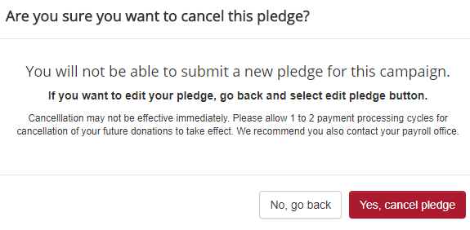

4. Select and click on *Yes, cancel pledge* to continue.

5. The system will confirm your cancelation instruction at the top of the Your Pledge screen:

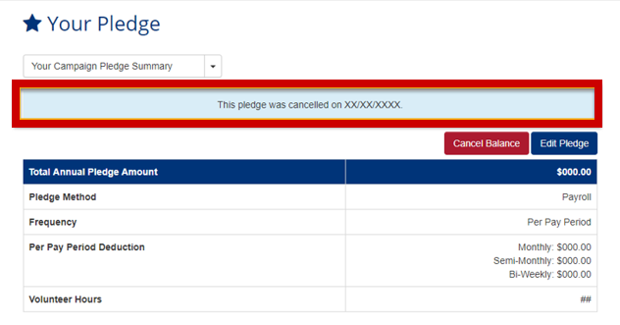

# **Retrieving Forgotten Username**

If at any time the username/primary email is forgotten, users can have an email sent to their secondary email reminding them of their username. To request a username reminder:

1. Select and click on the *Forgot Email?* link from the login page.

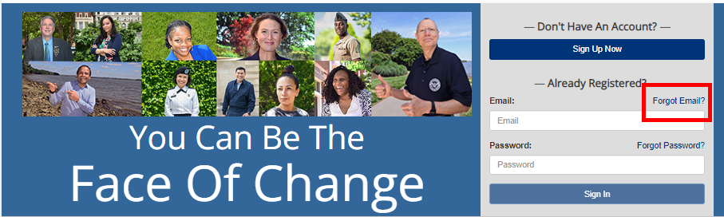

2. Enter the secondary email registered, and the system will send a reminder with your primary email as a reminder.

3. Follow the directions in the email.

**If secondary email is also forgotten, please submit a Contact Us form for technical support.**

**A link to the form is located on the upper right-hand side of the screen.**

# **Requesting Temporary Password**

If at any time a password is forgotten, users can have an email sent to their primary email address with a temporary password. To request a temporary password:

1. Select and click on the *Forgot Password?* link from the login page.

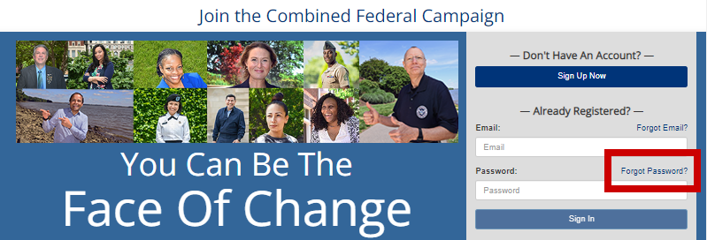

1. Enter the email used to register, and the system will send a temporary password via email.

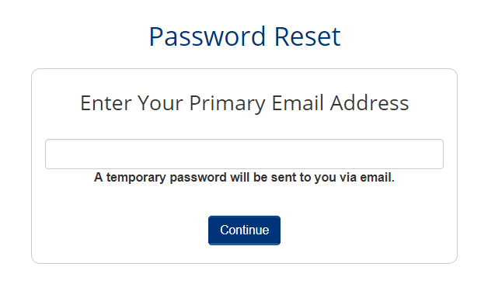

1. Follow the directions sent in the temporary password email.

# **Submitting Group Volunteer Pledge**

Users can submit a pledge on behalf of a group that will be completing a volunteer activity.

1. Log in using the established Username and Password credentials
2. Select the option for “Submit Group Volunteer Pledge” at the bottom of the screen
3. Proceed through with entering the relevant details about the volunteer efforts:
4. Enter the CFC Code associated with hours being pledged
   1. Department, Agency & Office (D/A/O)
      1. Add a new line for each different D/A/O Grouping (max. 10 rows)
   2. Number of Volunteers from each D/A/O Group
   3. Total Number of Hours Pledged by each D/A/O Group

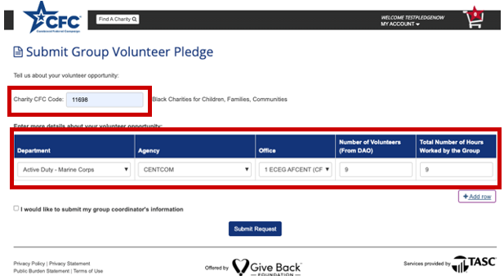

1. Once all data has been entered, please click **SUBMIT REQUEST**.
   1. The user will be offered the option to submit the Group Coordinator’s Information.

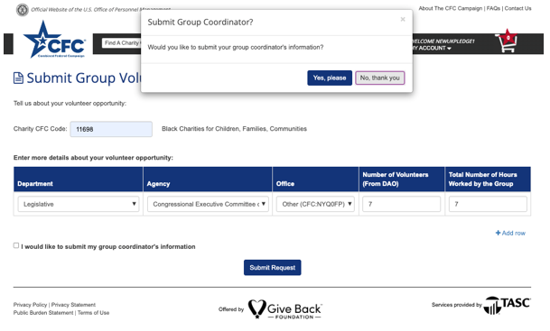

* 1. If **YES**, the user will be prompted to provide that data

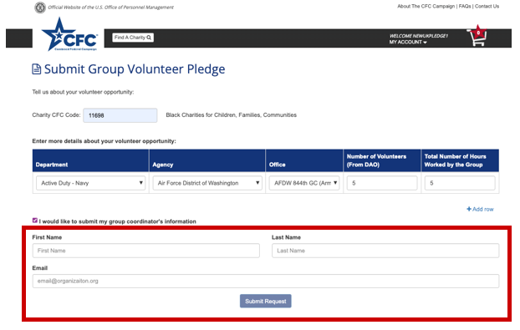

* 1. The user will be provided the opportunity to make a monetary pledge to this charity or another of his or her choice. Please select accordingly.

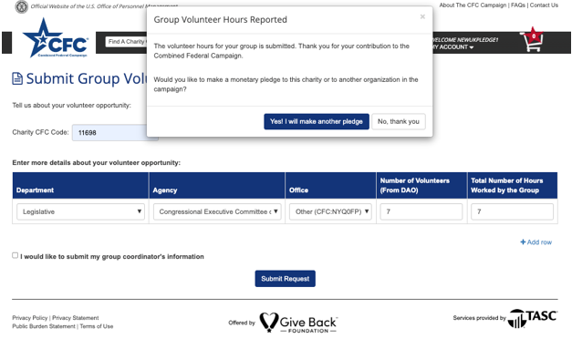

# **Reporting Group Volunteer Hours Completed**

Once the volunteer event is completed, users can report the hours worked.

1. Log in using the established Username and Password credentials
2. Select the option for “Report My Volunteer Hours” to the right

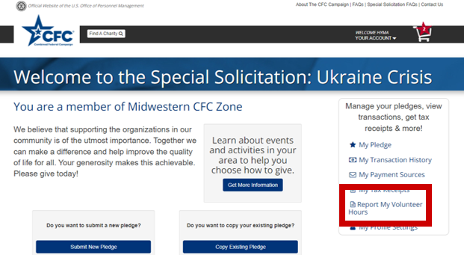

1. Complete the Required fields and then click “Submit Volunteer Hours” at the bottom of the screen.

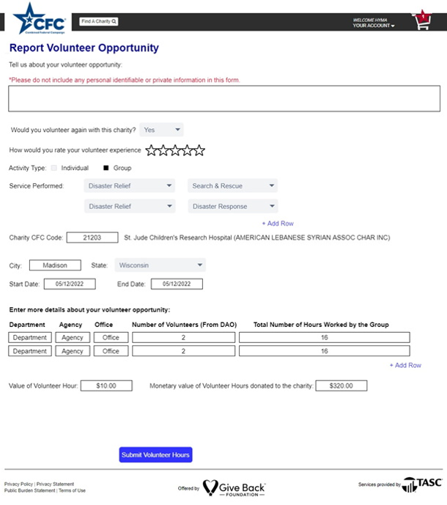

# **Text to Give**

In addition to the online pledging system, users can utilize the Text-To-Give Feature

1. Text **DONATE** to **978-487-5678**
   1. Link #1 will take the user through the One-Time Credit Card **Text-To-Give** workflow
   2. Link #2 will take the user to the mobile version of the full CFC Website to:
      1. Set up a pledge account
      2. Log into the current Pledge Account
      3. Set up recurring ACH/CC or Payroll Deductions

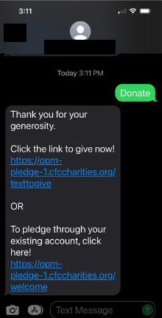

Link #1 Homepage Link #2 Homepage

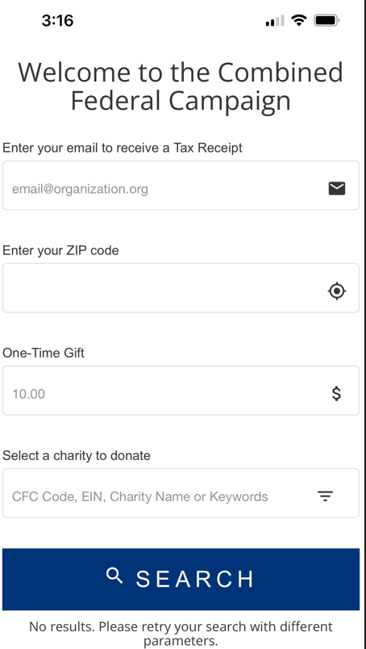 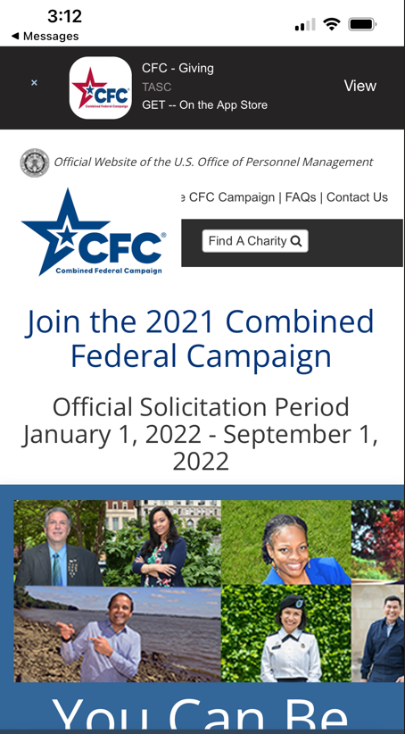

1. Select Link #1 to proceed through the Text-To-Give Prompts

*(All fields will be validated upon submission)*

* 1. Enter Email for a Tax Receipt
  2. Enter Zip Code
  3. Enter Amount Pledged *(0.00 format)*
  4. Enter CFC Code, Charity Name, or Keyword for search
     1. Use the filtering option to decrease the number of search results returned

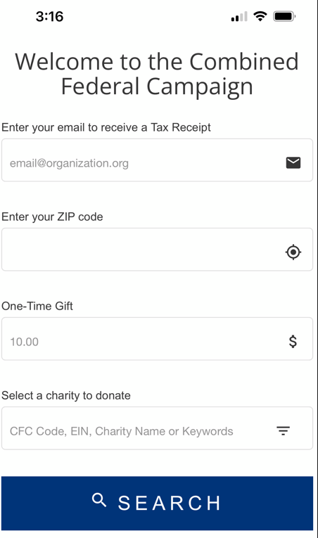 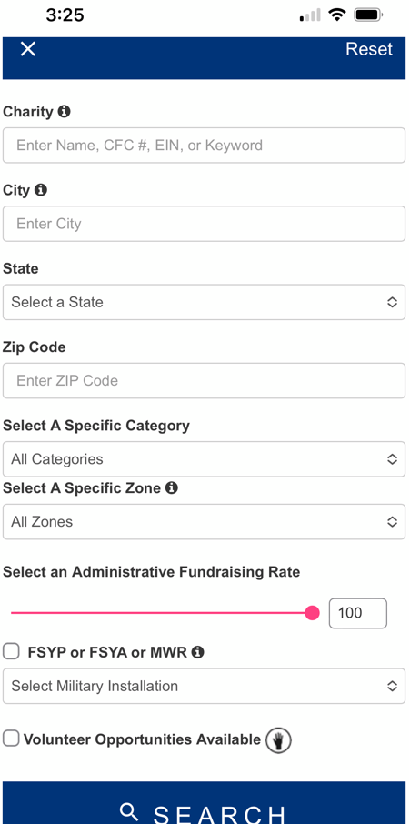

**Search Filter**

1. Once the charity is located, choose the SELECT option at the bottom of the screen

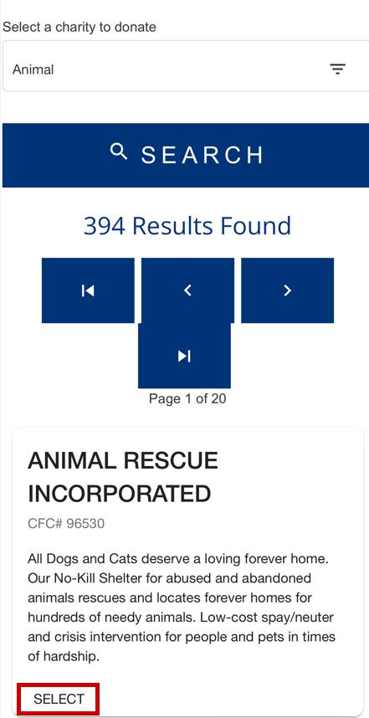

1. Once all pledge and charity details are entered, select CONTINUE to proceed to the payment screen

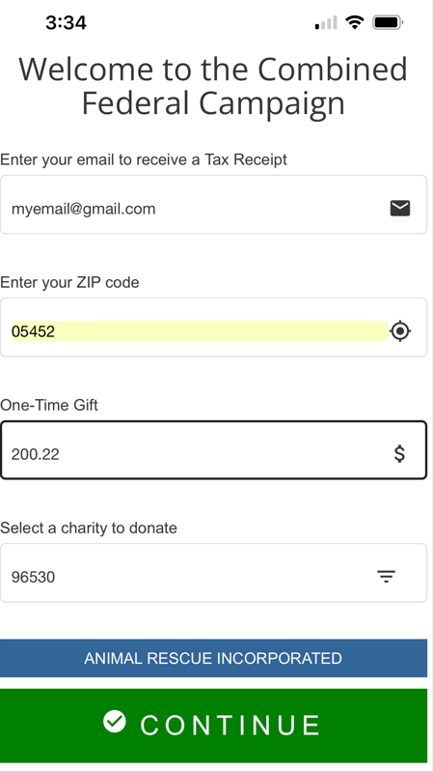

1. Payment options are PayPal or Credit Card
   1. Once a payment option is selected and completed, select **SUBMIT**

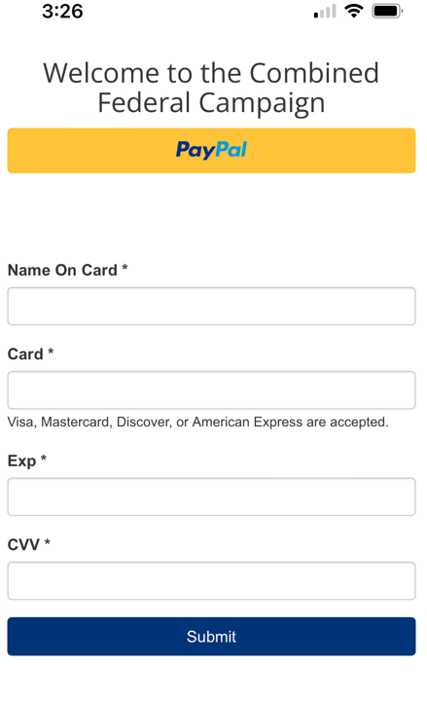

1. When payment is processed, a confirmation screen will appear

